AISC Shapes Database
Versions 14.1 and 14.1H
Read Me File

October 2013



AMERICAN INSTITUTE OF STEEL CONSTRUCTION
One East Wacker Drive, Suite 700, Chicago, Illinois 60601
AISC© 2013

by

American Institute of Steel Construction

All rights reserved. This electronic file or any part thereof must not be reproduced in any form without
the written permission of the publisher. The AISC logo is a registered trademark of AISC.

The information presented in these electronic files has been prepared in accordance with recognized engineering principles and is for general information only. While it is believed to be accurate, this information should not be used or relied upon for any specific application without competent professional examination and verification of its accuracy, suitability, and applicability by a licensed professional engineer, designer, or architect. The publication of the material contained herein is not intended as a representation or warranty on the part of the American Institute of Steel Construction or of any other person named herein, that this information is suitable for any general or particular use or of freedom from infringement of any patent or patents. Anyone making use of this information assumes all liability arising from such use.

Caution must be exercised when relying upon other specifications and codes developed by other bodies and incorporated by reference herein since such material may be modified or amended from time to time subsequent to the production of these electronic files. The Institute bears no responsibility for such material other than to refer to it and incorporate it by reference at the time of the initial publication of this edition.

Produced in the United States of America

AISC Shapes Database Version 14.1

Version 14.1 (V14.10) contains current section dimensions and properties consistent with the AISC Steel Construction Manual, 14th Edition, 3rd printing. The AISC Shapes Database Version 14.1 is available in Microsoft Excel format.

Improvements in V14.1 include:

- Addition of single angle dimensions: w_{a}, w_{b}, w_{c}, z_{a}, z_{b}, and z_{c}
- Revised symbols for width, height and slenderness ratio for HSS
  - B = nominal width
  - b = flat wall width
  - b / t_{des} = width-to-thickness ratio
  - Ht = nominal height
  - h = flat wall height
  - h / t_{des} = height-to-thickness ratio

AISC Shapes Database Version 14.1H

Version 14.1H (V14.1H) contains historic dimensions and section properties for shapes produced from 1873 – 2005. It does not contain current shape properties for use in the design of structural steel for new construction. See AISC Shapes Database V14.1 for this information.

Properties in V14.1H are taken from:

Iron and Steel Beams 1873 to 1952, 1953
AISC Steel Construction Manual, 5th Edition, 1962
AISC Steel Construction Manual, 6th Edition, 1964
AISC Steel Construction Manual, 7th Edition, 1970
AISC Steel Construction Manual, 8th Edition, 1980
AISC Manual of Steel Construction, 9th Edition, Allowable Stress Design, 1989
AISC Manual of Steel Construction, 1st Edition Load and Resistance Factor Design, 1986
AISC Manual of Steel Construction, 2nd Edition Load and Resistance Factor Design, 1994
AISC Manual of Steel Construction, 3rd Edition, 2001
AISC Steel Construction Manual, 13th Edition, 2005

The AISC Shapes Database V14.1H is available in Microsoft Excel format.

Directions for Reading AISC Shapes Database Version 14.1 (14th Edition Steel Construction Manual Dimensions and Section Properties only)

Dimensions and properties for each shape are listed sequentially in a single row. The data in each column is as follows (the corresponding columns representing equivalent metric properties are listed in parentheses).

Column A Type – the shape type, e.g., W, C, L, etc.
Column B (CB) EDI_Std_Nomenclature – the shape designation according to the
AISC Naming Convention for Structural Steel Products for Use in
Electronic Data Interchange (EDI), June 25, 2001. This information
is intended solely for the use of software developers to facilitate the
electronic labeling of shape-specific data and electronic transfer of
that data.
Column C (CC) AISC_Manual_Label – the shape designation as seen in the AISC
Steel Construction Manual, 14th Edition. The exception to this
is the designation for double angles. There is a separate listing
(row) for each back-to-back spacing and configuration. Therefore, the
shape designation reflects these two variables. The listings for
double angles follow the convention specified in the AISC Naming
Convention for Structural Steel Products for Use in Electronic Data
Interchange (EDI), June 25, 2001.
Column D T_F – A true/false variable. A value of T (true) indicates that there is
a special note for that shape (see below). A value of F (false)
indicates that there is not a special note for that shape.
Special notes:
W-shapes: a value of T indicates that the shape has a flange thickness greater than 2 in.
M-shapes: a value of T indicates that the shape has sloped flanges.
WT-shapes: a value of T indicates that the shape has a flange thickness greater than 2 in.
MT-shapes: a value of T indicates that the shape has sloped flanges.
Column E (CD) W – Nominal weight, lb/ft (kg/m)
Column F (CE) A – Cross-sectional area, in.² (mm²)
Column G (CF) d – Overall depth of member, or width of shorter leg for angles, or width of the outstanding legs of long legs back-to-back double angles, or the width of the back-to-back legs of short legs back-to-back double angles, in. (mm)
Column H (CG) d_{det} – Detailing value of member depth, in. (mm)
Column I (CH) Ht – Overall depth of square or rectangular HSS, in. (mm)
Column J (CI) h – Depth of the flat wall of square or rectangular HSS, in. (mm)
Column K (CJ) OD – Outside diameter of round HSS or pipe, in. (mm)
Column L (CK) b_{f} – Flange width, in. (mm)
Column M (CL) b_{fdet} – Detailing value of flange width, in. (mm)
Column N (CM) B – Overall width of square or rectangular HSS (the same as B per the 2010 AISC Specification), in. (mm)
Column O (CN) b – Width of the flat wall of square or rectangular HSS, or width of the longer leg for angles, or width of the back-to-back legs of long legs back-to-back double angles, or width of the outstanding legs of short legs back-to-back double angles, in. (mm)
Column P (CO) ID – Inside diameter of round HSS or pipe, in. (mm)
Column Q (CP) t_{w} – Web thickness, in. (mm)
Column R (CQ) t_{wdet} – Detailing value of web thickness, in. (mm)
Column S (CR) t_{wdet}/2 – Detailing value of t_{w}/2, in. (mm)
Column T (CS) t_{f} – Flange thickness, in. (mm)
Column U (CT) t_{fdet} – Detailing value of flange thickness, in. (mm)
Column V (CU) t – Thickness of angle leg, in. (mm)
Column W (CV) t_{nom} – HSS and pipe nominal wall thickness, in. (mm)
Column X (CW) t_{des} – HSS and pipe design wall thickness, in. (mm)
Column Y (CX) k_{des} – Design distance from outer face of flange to web toe of fillet, in. (mm)
Column Z (CY) k_{det} – Detailing distance from outer face of flange to web toe of fillet, in. (mm)
Column AA (CZ) k₁ - Detailing distance from center of web to flange toe of fillet, in. (mm)
Column AB (DA) x – Horizontal distance from designated member edge, as defined in the AISC Steel Construction Manual, to member centroidal axis, in. (mm)
Column AC (DB) y – Vertical distance from designated member edge, as defined in the AISC Steel Construction Manual, to member centroidal axis, in. (mm)
Column AD (DC) e_{o} – Horizontal distance from designated member edge, as defined in the AISC Steel Construction Manual, to member shear center, in. (mm)
Column AE (DD) x_{p} – Horizontal distance from designated member edge, as defined in the AISC Steel Construction Manual, to member plastic neutral axis, in. (mm)
Column AF (DE) y_{p} – Vertical distance from designated member edge, as defined in the AISC Steel Construction Manual, to member plastic neutral axis, in. (mm)
Column AG (DF) b_{f}/2t_{f} – Slenderness ratio
Column AH (DG) b/t – Slenderness ratio for single angles
Column AI (DH) b/t_{des} – Slenderness ratio for square or rectangular HSS
Column AJ (DI) h/t_{w} – Slenderness ratio
Column AK (DJ) h/t_{des} – Slenderness ratio for square or rectangular HSS
Column AL (DK) D/t – Slenderness ratio for round HSS and pipe, or tee shapes
Column AM (DL) I_{x} – Moment of inertia about the x-axis, in.⁴ (mm⁴ /10⁶)
Column AN (DM) Z_{x} – Plastic section modulus about the x-axis, in.³ (mm³ /10³)
Column AO (DN) S_{x} – Elastic section modulus about the x-axis, in.³ (mm³ /10³)
Column AP (DO) r_{x} – Radius of gyration about the x-axis, in. (mm)
Column AQ (DP) I_{y} – Moment of inertia about the y-axis, in.⁴ (mm⁴ /10⁶)
Column AR (DQ) Z_{y} – Plastic section modulus about the y-axis, in.³ (mm³ /10³)
Column AS (DR) S_{y} – Elastic section modulus about the y-axis, in.³ (mm³ /10³)
Column AT (DS) r_{y} – Radius of gyration about the y-axis (with no separation for double angles back-to-back), in. (mm)
Column AU (DT) I_{z} – Moment of inertia about the z-axis, in.⁴ (mm³ /10⁶)
Column AV (DU) r_{z} – Radius of gyration about the z-axis, in. (mm)
Column AW (DV) S_{z} – Elastic section modulus about the z-axis, in.³ (mm³ /10³)
Column AX (DW) J – Torsional moment of inertia, in.⁴ (mm⁴ /10³)
Column AY (DX) C_{w} – Warping constant, in.⁶ (mm⁶ /10⁹)
Column AZ (DY) C – HSS torsional constant, in.³ (mm³ /10³)
Column BA (DZ) W_{no} – Normalized warping function, as used in Design Guide 9, in.² (mm²)
Column BB (EA) S_{w1} – Warping statical moment at point 1 on cross section, as used in Design Guide 9 and shown in Figures 1 and 2, in.⁴ (mm⁴ /10⁶)
Column BC (EB) S_{w2} – Warping statical moment at point 2 on cross section, as used in Design Guide 9 and shown in Figure 2, in.⁴ (mm⁴ /10⁶)
Column BD (EC) S_{w3} – Warping statical moment at point 3 on cross section, as used in Design Guide 9 and shown in Figure 2, in.⁴ (mm⁴ /10⁶)
Column BE (ED) Q_{f} – Statical moment for a point in the flange directly above the vertical edge of the web, as used in Design Guide 9, in.³ (mm³ /10³)
Column BF (EE) Q_{w} – Statical moment for a point at mid-depth of the cross section, as used in Design Guide 9, in.³ (mm³ /10³)
Column BG (EF) r_{o} – Polar radius of gyration about the shear center, in. (mm)
Column BH (EG) H – Flexural constant
Column BI (EH) tan(α) – Tangent of the angle between the y-y and z-z axes for single angles, where α is shown in Figure 3
Column BJ (EI) Q_{s} – Reduction factor for slender unstiffened compression elements
Column BK (EJ) I_{w} – Moment of inertia about the w-axis, in.⁴ (mm⁴ /10⁶)
Column BL (EK) z_{A} – Distance from point A to center of gravity along z-axis, as
shown in Figure 3, in. (mm)
Column BM (EL) z_{B} – Distance from point B to center of gravity along z-axis, as
shown in Figure 3, in. (mm)
Column BN (EM) z_{C} – Distance from point C to center of gravity along z-axis, as
shown in Figure 3, in. (mm)
Column BO (EN) w_{A} – Distance from point A to center of gravity along w-axis, as
shown in Figure 3, in. (mm)
Column BP (EO) w_{B} – Distance from point B to center of gravity along w-axis, as
shown in Figure 3, in. (mm)
Column BQ (EP) w_{C} – Distance from point C to center of gravity along w-axis, as
shown in Figure 3, in. (mm)
Column BR (EQ) S_{wA} – Elastic section modulus about the w-axis at point A on cross section, as
shown in Figure 3, in.³ (mm³ /10³)
Column BS (ER) S_{wB} – Elastic section modulus about the w-axis at point B on cross section, as
shown in Figure 3, in.³ (mm³ /10³)
Column BT (ES) S_{wC} – Elastic section modulus about the w-axis at point C on cross section, as
shown in Figure 3, in.³ (mm³ /10³)
Column BU (ET) S_{zA} – Elastic section modulus about the z-axis at point A on cross section, as
shown in Figure 3, in.³ (mm³ /10³)
Column BV (EU) S_{zB} – Elastic section modulus about the z-axis at point B on cross section, as
shown in Figure 3, in.³ (mm³ /10³)
Column BW (EV) S_{zC} – Elastic section modulus about the z-axis at point C on cross section, as
shown in Figure 3, in.³ (mm³ /10³)
Column BX (EW) r_{ts} – Effective radius of gyration, in. (mm)
Column BY (EX) h_{o} – Distance between the flange centroids, in. (mm)
Column BZ (EY) P_{A} – Shape perimeter minus one flange surface, as used in Design Guide 19, in. (mm)
Column CA (EZ) P_{B} – Shape perimeter, as used in Design Guide 19, in. (mm)

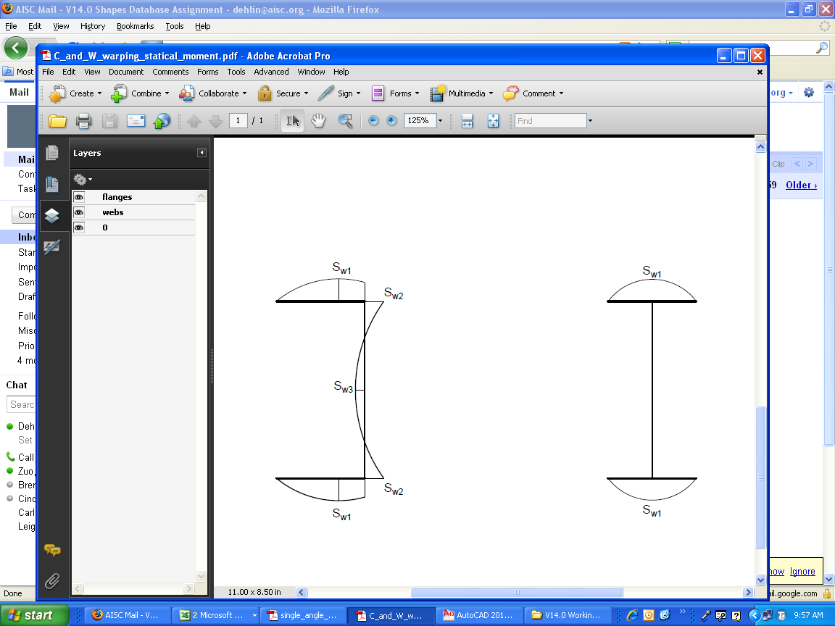  Fig. 1. Location of warping statical moment for W-, M-, S- and HP-shapes. | Fig. 2. Locations of warping statical moment for C- and MC-shapes.
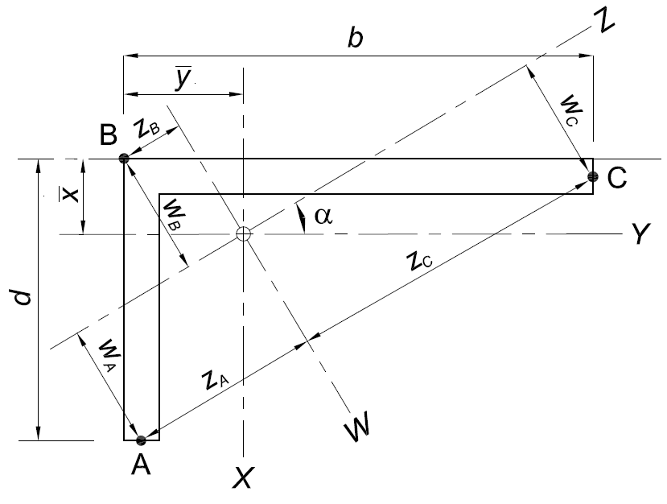
Fig. 3. Locations of points A, B and C for single angles.

Directions for Reading Database Version 14.0H (Historic Dimensions and Section Properties 1873-2005)
Dimensions and properties for each shape are listed sequentially in a single row.

Column A Edition – Source document from which the section properties have been compiled, corresponding to the following:
13th - AISC Steel Construction Manual, 13th Edition, 2005
LRFD3 - AISC Manual of Steel Construction, 3rd Edition, Load and Resistance
Factor Design, 2001
LRFD2 - AISC Manual of Steel Construction, 2nd Edition, Load and Resistance
Factor Design, 1994
ASD9 - AISC Manual of Steel Construction, 9th Edition,
Allowable Stress Design, 1989
LRFD1 - AISC Manual of Steel Construction, 1st Edition, Load and Resistance
Factor Design, 1986
ASD8 - AISC Steel Construction Manual, 8th Edition, 1980
ASD7 - AISC Steel Construction Manual, 7th Edition, 1970
ASD6 - AISC Steel Construction Manual, 6th Edition, 1964
ASD5 - AISC Steel Construction Manual, 5th Edition, 1962
Historic - Iron and Steel Beams 1873 to 1952, 1953

Column B Footnote – In ASD5, ASD6, ASD7, ASD8, ASD9, LRFD1, LRFD2 and LRFD3 Editions, this refers to special considerations for the listed section that must be used in design. For Historic Sections, this refers to the shape producer, as listed in the producer key of Design Guide 15 (available at www.aisc.org/epubs).

Column C Type – Shape type, as summarized by the following:

Shape Type | Description
2L | Double Angle Section
B | Miscellaneous Beam Section
BCB | Both B and CB Sections
BJ | Miscellaneous Joist Section
BL | Miscellaneous Light Beam Section
BLB | Miscellaneous Light Beam Section
BP | Bearing Pile Section
BWF | Miscellaneous Wide-Flange Section
C | Channel Section
CB | Carnegie Beam Section
G | Girder Section
HP | H-Pile Section
HSS | Hollow Structural Section
I | I Section
J | Junior Section
Jr | Junior Beam Section
JRC | Junior Column Section
JrU | Junior Channel Section
L | Angle Section
LWF | Light WF and Miscellaneous Column Sections
M | Miscellaneous Section
MC | Miscellaneous Channel Section
MT | Structural Tee Section split from M-Shape
P | Standard Pipe Section
PIPE | Structural Pipe Section
S | American Standard Beam Shape
ST | Structural Tees Split from S-Shapes
ST B | Structural Tees Split from B-Shapes
ST I | Structural Tees Split from I-Shapes
ST Jr | Structural Tees Split from Jr-Shapes
ST M | Structural Tees Split from M-Shapes
ST R | Rectangular Structural Tubing Section
ST S | Square Structural Tubing Section
ST WF | Structural Tees Split from WF-Shapes
T FS | Tee Section (Flange by Stem)
U | American Standard Channel Sections
W | Wide-Flange Section
WF | Wide-Flange Section
WFB | Both WF and B Sections
WFCB | Both WF and CB Sections
WT | Structural Tees Split from W-Shape
XP | Extra Strong Pipe Section
XXP | Double-Extra Strong Pipe Section
Z | Z-Section

Columns D through J Designation - Shape Label as listed in the AISC Manual or in Iron and Steel Beams 1873-1952.
Column K A – Cross-sectional area, in.²
Column L d – Overall depth of member (longer leg for angles), in.
Column M t_{w} – Web thickness, in.
Column N t_{w}/2 – Web half-thickness, in.
Column O b_{f} – Flange width, in.
Column P t_{f} – Flange thickness, in.
Column Q T – Detailing depth between the web toes of the fillets, in.
Column R k – Detailing distance from outer face of flange to web toe of fillet, in.
Column S k₁ – Detailing distance from center of web to flange toe of fillet, in.
Column T W – Weight, lb/ft
Column U b_{f}/2t_{f} – Slenderness ratio
Column V h/t_{w} – Slenderness ratio
Column W F_{y}′′′ – The theoretical maximum yield stress based on the web depth-thickness ratio (h / t_{w}) above which the web of a column is considered a slender element, ksi
Column X X₁ – Beam buckling factor, ksi
Column Y X₂ – Beam buckling factor, (1/ksi² × 10⁶)
Column Z I_{x} – Moment of inertia about the x-axis, in.⁴
Column AA Z_{x} – Plastic section modulus about the x-axis, in.³
Column AB S_{x} – Elastic section modulus about the x-axis, in.³
Column AC r_{x} – Radius of gyration about the x-axis, in.
Column AD y – Vertical distance from designated member edge, as defined in the AISC Steel Construction Manual, to centroidal axis, in.
Column AE y_{p} –Vertical distance from designated member edge, as defined in the AISC Steel Construction Manual, to plastic neutral axis, in.
Column AF I_{y} – Moment of inertia about the y-axis, in.⁴
Column AG Z_{y} – Plastic section modulus about the y-axis, in.³
Column AH S_{y} – Elastic section modulus about the y-axis, in.³
Column AI r_{y} – Radius of gyration about the y-axis, in.
Column AJ x – Horizontal distance from designated member edge, as defined in the AISC Steel Construction Manual, to centroidal axis, in.
Column AK x_{p} – Horizontal distance from designated member edge, as defined in the AISC Steel Construction Manual, to plastic neutral axis, in.
Column AL r_{z} – Radius of gyration about the z-axis, in.
Column AM maxf – Maximum flange fastener, in.
Column AN Grip – Grip, in.
Column AO e_{o} – Horizontal distance from designated edge of member to shear center location, in.
Column AP Q_{s36} – Reduction factor for slender unstiffened compression elements in members other than double angles for 36 ksi material
Column AQ Q_{s50} – Reduction factor for slender unstiffened compression elements in members other than double angles for 50 ksi material
Column AR Q_{s36c}* – Reduction factor for slender unstiffened compression elements for 36 ksi material with angles in contact
*Where no value of Q_{s} is shown for applicable sections, the angles comply with the noncompact section criteria of the AISC Specification and may be considered fully effective.
Column AS Q_{s50c}* – Reduction factor for slender unstiffened compression elements for 50 ksi material with angles in contact
*Where no value of Q_{s} is shown for applicable sections, the angles comply with the noncompact section criteria of the AISC Specification and may be considered fully effective.
Column AT Q_{s36s}* – Reduction factor for slender unstiffened compression elements for 36 ksi material with angles separated
*Where no value of Q_{s} is shown for applicable sections, the angles comply with the noncompact section criteria of the AISC Specification and may be considered fully effective.
Column AU Q_{s50s}* – Reduction factor for slender unstiffened compression elements for 50 ksi material with angles separated
*Where no value of Q_{s} is shown for applicable sections, the angles comply with the noncompact section criteria of the AISC Specification and may be considered fully effective.
Column AV A_{stem} – Stem cross-sectional area for a tee, in.²
Column AW tan(α) – Tangent of the angle between the y-y and z-z axes for single angles
Column AX t_{wstem} – Stem thickness for a tee or Z-section, in.
Column AY t_{wstem}/2 – Stem half-thickness for a tee, in.
Column AZ OD – Outside diameter, in.
Column BA ID – Inside diameter, in.
Column BB t_{wall} – Wall thickness, in.
Column BC J – Torsional moment of inertia, in.⁴
Column BD t – Thickness, in.
Column BE I_{y}′ – Moment of inertia about the y-y axis for bearing piles, in.⁴
Column BF S_{y}′ – Elastic section modulus about the y-y axis for bearing piles, in.³
Column BG r_{y}′– Radius of gyration about the y-y axis for bearing piles, in.
Column BH sched –ASA Schedule Number
Column BI A_{net36} – Theoretical net area for ASTM A36 material based on Section 1.9.1 of the AISC Specification in the 6th Edition AISC Manual, in.²
Column BJ d_{1A36} – Theoretical depth of tee for ASTM A36 material based on Section 1.9.1 of the AISC Specification in the 6th Edition AISC Manual, in.
Column BK I_{xA36} – Theoretical moment of inertia about the x-x axis for ASTM A36 material based on Section 1.9.1 of the AISC Specification in the 6th Edition AISC Manual, in.⁴
Column BL S_{xA36} – Elastic section modulus about the x-x axis based on Section 1.9.1 of the AISC Specification in the 6th Edition AISC Manual, in.³
Column BM r_{xA36} – Theoretical radius of gyration about the x-x axis for ASTM A36 material based on Section 1.9.1 of the AISC Specification in the 6th Edition AISC Manual, in.
Column BN y_{1A36} – Theoretical distance from the neutral axis to the centroid of a section about the x-x axis for ASTM A36 material based on Section 1.9.1 of the AISC Specification in the 6th Edition AISC Manual, in.
Column BO r_{yA36} –Theoretical radius of gyration about the y-y axis for ASTM A36 material based on Section 1.9.1 of the AISC Specification in the 6th Edition AISC Manual, in.
Column BP A_{netASTM} – Theoretical net area for ASTM A242, A440 and A441 materials based on Section 1.9.1 of the AISC Specification in the 6th Edition AISC Manual, in.²
Column BQ d_{1ASTM} – Theoretical depth of tee for ASTM A242, A440 and A441 materials based on Section 1.9.1 of the AISC Specification in the 6th Edition AISC Manual, in.
Column BR I_{xASTM} – Theoretical moment of inertia about the x-x axis for ASTM A242, A440 and A441 materials based on Section 1.9.1 of the AISC Specification in the 6th Edition AISC Manual, in.⁴
Column BS S_{xASTM} – Theoretical section modulus about the x-x axis for ASTM A242, A440 and A441 materials based on Section 1.9.1 of the AISC Specification in the 6th Edition AISC Manual, in.³
Column BT r_{xASTM} – Theoretical radius of gyration about the x-x axis for ASTM A242, A440 and A441 materials based on Section 1.9.1 of the AISC Specification in the 6th Edition AISC Manual, in.
Column BU y_{1ASTM} – Theoretical distance from the neutral axis to the centroid of a section about the x-x axis for ASTM A242, A440 and A441 materials based on Section 1.9.1 of the AISC Specification in the 6th Edition AISC Steel Construction Manual, in.
Column BV r_{yASTM} – Theoretical radius of gyration about the y-y axis for ASTM A242, A440 and A441 materials based on Section 1.9.1 of the AISC Specification in the 6th Edition AISC Steel Construction Manual, in.
Column BW d/t – Slenderness ratio
Column BX r_{y0} – Polar radius of gyration, in.
Column BY r_{y1_4} – Radius of gyration about the y-y axis for angles separated by 4 in., in.
Column BZ r_{y3_8} – Radius of gyration about the y-y axis for angles separated by a in., in.
Column CA r_{y1_2} – Radius of gyration about the y-y axis for angles separated by 2 in., in.
Column CB r_{y5_8} – Radius of gyration about the y-y axis for angles separated by a in., in.
Column CC r_{y3_4} – Radius of gyration about the y-y axis for angles separated by w in., in.
Column CD d/A_{f} – Depth divided by flange area, in.⁻¹
Column CE r_{T} – Radius of gyration of a section comprising the compression flange plus one-third of the compression web area, taken about an axis in the plane of the web, in.
Column CF F_{y}′′ – Theoretical maximum yield stress based on the width-thickness ratio of the web, beyond which a particular shape is not “compact”, ksi
Column CG C_{w} – Warping constant for a section, in.⁶
Column CH F_{y}′ –Theoretical maximum yield stress based on the width-thickness ratio of one-half the unstiffened compression flange, beyond which a particular shape is not “compact,” ksi
Column CI C_{c50}′– Column slenderness ratio dividing elastic and inelastic buckling, modified to account for effective width of wide compression elements for 50 ksi material
Column CJ C_{c36}′– Column slenderness ratio dividing elastic and inelastic buckling, modified to account for effective width of wide compression elements for 36 ksi material
Column CK a – Torsion property, in.; 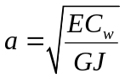
Column CL W_{no} – Normalized warping constant, in.²
Column CM S_{w} – Warping statical moment, in.⁴
Column CN Q_{f} – Statical moment at point in flange, in.³
Column CO Q_{w} – Statical moment at mid-depth of the section, in.³
Column CP B – Overall width of member (shorter leg for angles), in.
Column CQ Ht/t – Slenderness ratio for HSS
Column CR Ht – Depth of HSS, in.
Column CS t_{nom} – HSS nominal wall thickness, in.
Column CT t_{des} – HSS design wall thickness, in.
Column CU b/t – Slenderness ratio for HSS
Column CV C – HSS torsional constant, in.³
Column CW r_{o} – Polar radius of gyration about the shear center, in.
Column CX H – Flexural constant
Column CY d_{det} – Detailing value of member depth, in.
Column CZ b_{fdet} – Detailing value of flange width, in.
Column DA t_{wdet} – Detailing value of web thickness, in.
Column DB t_{fdet} – Detailing value of flange thickness, in.
Column DC k_{des} – Design distance from outer face of flange to web toe of fillet, in.
Column DD k_{det} – Detailing distance from outer face of flange to web toe of fillet, in.
Column DE B/t – Slenderness ratio for HSS
Column DF S_{z} – Elastic section modulus about the z-axis for single angles, in.³
Column DG Q_{s} – Reduction factor for slender unstiffened compression elements

Steel Producer Information
Information on steel producers was provided in the many early editions of Steel Construction Manual. In addition to the main worksheet of historic shapes in Shapes Database V14.1H, there are additional pages that show specifically the shapes that were produced by each major mill. The 8th edition of the ASD Steel Construction Manual was the last publication to provide this information.

EDI Naming Convention
“EDI Naming Convention.pdf” is a naming convention that standardizes the electronic descriptions used to identify structural steel shapes and other steel products.

